Student Name: Udaya Bhaskar Reddy Malkannagari

Student ID: 13368171

Assessment 1

SEO and Google Ad-words Campaign Strategic Proposal

Part A – Business Profile

James Cook University is one of the leading public universities in Australia. It is established in the year 1961 in Townsville, Queensland. It has campuses spread across Australia and Asia. The locations include Townville, Cairns, Brisbane and Singapore. The University offers multiple courses of study in several disciplines which include, Arts and Social Sciences, Business and IT, Creative Media, HealthCare Sciences, Law and Governance and Psychology, to name a few. It offers under-graduate, post-graduate and PHD research programs at its various campuses to both local as well as international students.

***Services Offered:***

The current web page is related to the under-graduate course in Information Technology. This course is offered in three different locations which include Townsville, Cairns and Singapore. The duration of the course is varied. It can be either 3 years full time or can be completed on a part time basis. The study mode can be both on-campus or off-campus. Off campus study is a combination of online resources, printed material and other technologies. The student intakes happen in February and July (depending on the campuses, it may vary).

The users can interact with the webpage to get an overview of all the information available. The page allows the user to apply for the course online. The user can also enquire about the information of the specific course or directly call the toll-free number provided at the bottom of the page.

***Core Subjects Offered:***

The whole design of this course structure enhances the knowledge and technical skills that are essential for a student on his way to a brighter professional IT career. These are the selling points that drive a student to pursue this degree at the University. The webpage gives us a detailed list of the core subjects offered under this degree. Some of the core topics that are covered include, Data Mining, Programming, Network Security, Design Thinking, Content Management Systems, Gamification, Machine Learning and Data Science. Some other minor subjects like Human Computer Interaction and Games Design, Computer Science and Networking are also offered under this course. These subjects entice the students into making their choice based on their interests and willingness to learn a particular course of study.

***Potential users:***

The potential users of the webpage are mainly students between the age group of 18 and 30. They include both the male and the female students, irrespective of their gender. Information Technology is a vastly growing field of study and people show their appetite to learn the necessary skills even at a mature age (above 30). Even though these people represent a good number of all the potential users of the webpage, our main area of focus will be the age group mentioned above as they form the majority of the users who visit the website. Parents of the students will also form another core part of the customer database as they weigh in various educational options for their children.

We can look at the user personas of two of the potential users to the webpage. (Students and Parents)

***Student User Persona:***

* **Name:** Daniel - Finished Diploma at the Syracuse University

USA

* **Age:** 22 - Uses Tablet computer at school
* **Occupation:** Student - Wants a career as a Data Scientist
* **Area of Study:** Diploma in IT - Very adept at using the internet
* **Computer Literacy:** High - Quickly gets bored of any slowdowns while

loading pages and games

* Does not like scanning through the whole

webpages

***Parent User Persona:***

* Name: Aditi Roy - Senior web developer
* Age 48 - Wants to find a good university for her

daughter to study IT

* Occupation: Web Designer - Can understand the nuances of a good

website

* Computer Literacy: Very High - A well designed university website will

provide a good impression on her

* Work Experience: 20 years

***Potential benefits of the website:***

The potential benefits of having an effective website for the University are multifarious. Having a website will increase the chances to reach to more number of as compared to other marketing strategies. Primarily, it acts as a doorway for international students who desire to pursue a course at the University. They can gather valuable information about the kind of courses offered, the fee structure among other things. They even have the option to submit their curriculum vitae (CV), along with other necessary documents to apply for admission online. In the event of non-existence of such a working mechanism, students from different countries may not get a chance to get hands on information about the University or the degree of their choice.

Another advantage of having such an online system will be the accessibility to the user. It will allow for a 24-hour communication channel with the potential students and enables the University to offer guidance and support along the admission process or further enquiries. This will save a lot of time and investment both to the user and the University and ensures the quickening of the whole process. It is also a cost-effective solution to showcase the University’s goals and ideas, along with the courses offered, to a global audience. This will further enhance the reputation of the University.

Part B - SEO and User friendliness

User friendliness of the Website affects the Search Engine Optimization on how well it responds to Google ranking factors. We can look at some of the user-friendly features that can be improved upon to provide a more responsive SEO strategy.

***Navigation:*** The navigation of the webpage is a bit cumbersome. Upon opening the webpage, the user must scroll down to each and every sub section to get the required information. For example, if the user wants to access a course overview, he must scroll down and click on the respective tab to get information about it. This could be avoided by using a left side navigation bar that lists all the available options. The toll-free number is also highlighted at the bottom of the page which the user may easily skip if they don’t navigate to that part of the web page. (Image 2)

***Photographs:*** The webpage uses more textual content than pictures. The content can be overwhelming to a user who is scanning through the whole page. Use of images can be a good design choice to highlight the key elements of the webpage. One of the key factors to look at when using pictures is the alignment and consistency of the images used. Another guiding factor is to have size-optimized images which ensures faster loading times for the webpage. Images and videos greatly affect the loading time of the webpage. So, care needs to be taken to ensure that a decent quality image output with a definitive size is used.

Pictures affect human cognitive abilities. The picture at the background of the main course title has a shooting light image which might be a distraction to some of the users who are scanning through the webpage. Replacing it with a plain background or a relevant image can enhance the readability of the webpage.

Photographs also help in creating a brand awareness and brand positioning. Hence, optimum care must be taken while choosing a logo image for the University which is done well on the current webpage. (Image 3)

***Interactivity:***  Having an interactive webpage is essential to ensuring a long-term relationship with the user. This can be done by adding a chat tool box to the web page. This tool box can be placed as a pop up to the bottom right corner of the page. Any personalized queries can be answered with the use of such an online interface. Also, having user forums on the page can make it much more interactive to the users. The users can participate and read through the opinions of other users. This will greatly help in resolving several queries pertaining to student related issues.

***Meta Description Tag:*** Meta Descriptions are HTML attributes that provide concise explanations of the contents of web pages. Google selects a search snippet based on the particular search. However, by providing a meta description we have the option to create our own search snippet. Meta descriptions don’t count towards Google ranking but they do count towards getting users to click on the website.

We check two scenarios of the same course offered at two different locations, one in Australia and the other in Singapore.

First, we look at the current web page html meta tag from the website of the Australian campus. The description meta tag is empty as indicated in the Image 4.

We can also check the webpage for the Singapore campus offering the same course. (<https://www.jcu.edu.sg/courses-and-study/courses/course/bachelor-of-information-technology>)

(Image 5)

The description tag for this webpage contains the content detailing the key technologies offered in the degree (as seen in the image).

Now, if we try to search google by keying in,” James cook university, bachelor of information technology”, the Singapore domain name shows up higher than the Australian website. It implies that have a descriptive information about the website can help in getting more user clicks for the web page.

This issue can be resolved by inserting proper meta description as shown below:

<meta property = “og:description” content=”Undergraduate course in Bachelor of Information Technology. Core Subject modules include, Data mining, Programming, Network Security, Network Forensics, e-strategic Management, Design Thinking and Mobile Computing”>

***Mobile Website:*** The mobile webpage for this website shows some performance issues. When checked with some validated third-party software, the webpage was loading much slower in the mobile than on the windows PC. The loading times were almost 57% longer. Mobile responsiveness schemes must be implemented to provide optimum functionality. Reducing the size can improve mobile webpage performance.

***Mail Server Problem:*** There is also an error in the SMTP showcasing that it does not support TLS. This will affect the mail options in the webpage as the user can provide email address for constant feedback.

**Part C – Proposed AdWords Strategy**

Our AdWords strategy included 2 campaigns. One Campaign is for the IT degree course offered full time at the James Cook University. Other campaign is for the IT degree course offered part time at the University. The overall campaign structure is designed in a way to increase the number of visitors to the webpage based on their selective choices.

Campaign 1 is about the full time under graduate IT program offered at the university. We used multiple keywords to gauge the user traffic. We also used negative keywords that signify a more playful and sarcastic approach to education among the younger populace. Campaign 2 is primarily about the part time IT degree courses that are offered at the university. This campaign can be advertised as more related to working men and women, who intend to get a degree in Information Technology at the later stages of their career. This population includes the mature age students and the keywords/ negative keywords are designed keeping them in mind.

***Keyword Table:***

|  |  |  |
| --- | --- | --- |
| ***Campaign*** | ***Keyword*** | ***Negative Keyword*** |
| Full Time Courses | Bachelor in Information Technology, Information Technology Study, Information Systems, Study IT, undergraduate courses, courses in IT, IT degrees, IT education, Information Technology courses, full time degree, degree course, degree | No play  No games  No fun |
| Part time Courses | Part time courses in IT, Part time degree courses, study part time, Part time education, Part time degree, IT degree courses, Bachelor of IT, IT degree, Study IT | No work |

The negative keywords are designed in a way to indicate the relevant information that is not found on the university website. Using these keywords will not result in traffic to this webpage. (Image 7)

***AdWords Groups:***

Each Campaign has two AdWords groups.

The Fulltime Courses campaign includes 2 AdWords - 3 year degree and 2 year degree.

The Part Time Courses campaign includes 2 AdWords – Part time course, Off campus course

***Daily and Weekly Budget Plans:***

We have a spending budget of USD $250 for the three-weeks plan. We split the budget between the two campaigns. The primary campaign for a fulltime IT degree is allocated the majority of the budget (75%), as we consider it to reach a wider group of consumers and increase the traffic accordingly. The part time campaign takes the remaining 25 % of the total budget.

The budget and their daily and weekly spending are detailed in the table below.

|  |  |  |
| --- | --- | --- |
| ***Plan Type*** | ***Full time Courses (75%)*** | ***Part time Courses (25%)*** |
| Daily Plan | $8.92 per day | $2.97 per day |
| Weekly Plan | $62.9 per week | $20.8 per week |

At first, we thought of spending the budget incrementally at weekly intervals in time, but we discounted the fact because it’s only a three-week strategy and we needed a strong initial investment to draw in more number of visitors. And our marketing strategy seemed to have worked as we could see a 12 % increase in the number of visitors to the webpage.

***Network(s) for the AdWords ads:***

We set the campaign types as network only, to allow for a comprehensive viewer traffic from the google search. The ads include descriptions with keywords to highlight the relevant searching patterns that can draw in more users to the webpage. (Image 9)

***Target Audience settings:***

We set the target audience settings based on the default bids. The CPM and the CPC fields are left to blank to use the default bid settings. Target audience are mostly from the age groups between 18 and 30. These include international students who are willing to pursue their higher education abroad.

***Keyword bidding:***

We enabled keyword bidding and assigned bid amounts to the main advertising message for the “Full time Courses” campaign. The keyword used for this purpose is “Full time courses”

***Location Targeting:***

We set the target location to Australia.

***Impressions, Clicks, CPC and CTR:***

Here, we discuss the total budgets allocated for each campaign, the Click-through Rate (CTR) and the Cost per Click (CPC).

For Campaign 1, Full Time Courses, the daily cost of advertising comes around $ 8.11 to $ 9.02, and the weekly cost around $ 62.90. The total money that is spent on this campaign is $187.50. We used the network only setting to limit our search to the google world. We also used the “Optimize for Conversions” settings to enable the likely display of ads which produce conversions. We are using a targeted CPA bidding, and tried to augment the output with the use of this feature. The maximum CPC is set to use the default bid of $0.89. The overall clicks for the website is around 15.24 per day. And the impressions, which indicate the number of times the ads are shown up on the google search result page is around 236.70 per day. The CTR comes around 6.4% and the average cost per click (CPC) comes to $0.59. (Image 10/11)

***Success metrics:***

Then success metrics used to measure the performance of the whole marketing campaign depends on multiple factors. Primarily, we are satisfied with the increase in the number of visitors by 12% and the click through rate (CTR) of 6.4%. However, the impressions shown are still holding up on the lower side. This needs to be analyzed and new keyword strategies must be used to get those values into higher zones.

We also look at the conversion rate metrics that define the very purpose of having the website. The higher the conversion rate, the more the number of students who perform a user action (in this case, get admission into a course of choice). However, a large conversion rate may not guarantee a success as more and more money will be needed to spent on advertising. This diminishes the very purpose of having a cost-effective solution.

All in all, we can conclude that the marketing and design strategies used to improve the SEO and the google AdWords marketing campaign has helped us increase the user traffic to the website.

***References:***

Laudon, K. C., & Traver, C. G. (2010). E-Commerce: business, technology, society. Upper Saddle River, NJ: Pearson Education.

Holdren, A. (2012). Google AdWords. Sebastapol, CA: OReilly.

Williams, A. (2014). SEO: 2015 & beyond, search engine optimization will never be the same again! Charleston, SC: CreateSpace Independent Publishing Platform.

**APPENDIX**

Image 1 – showing the google space for both the jcu webpages

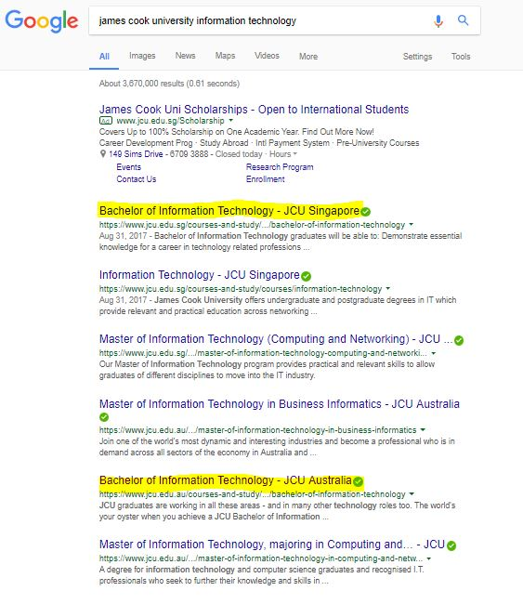

Image 2 – highlighting the navigation issues of the user

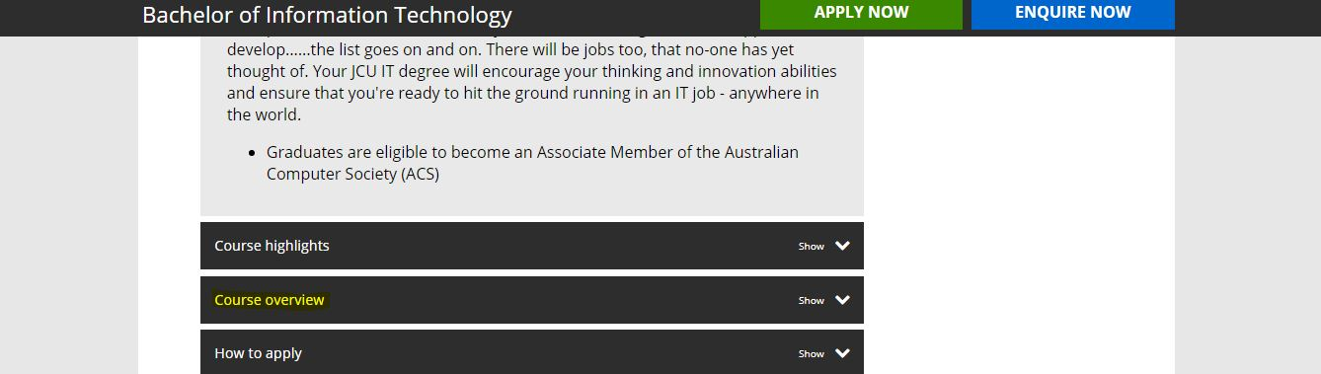

Image 3 – showing the shooting light picture in the background



Image 4 – description meta tag for the JCU Australia website

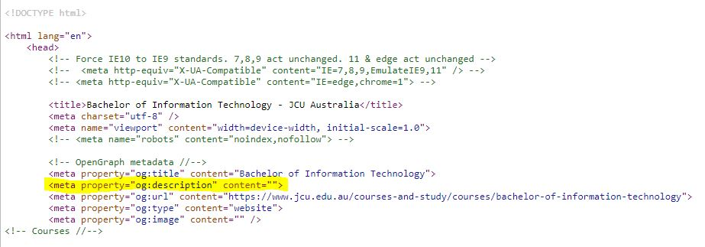

Image 5 – description meta tag for the JCU Singapore website

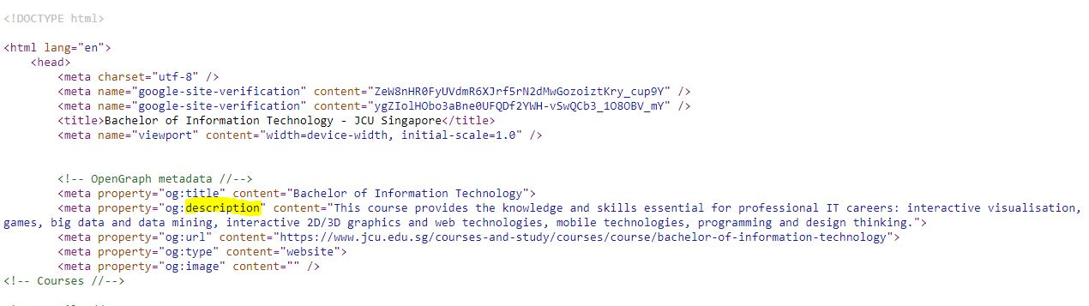

Image 6 – google AdWords implementation

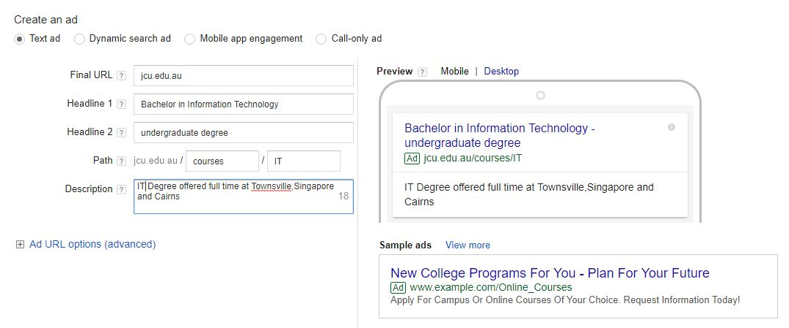

Image 7 – keywords for the fulltime courses campaign

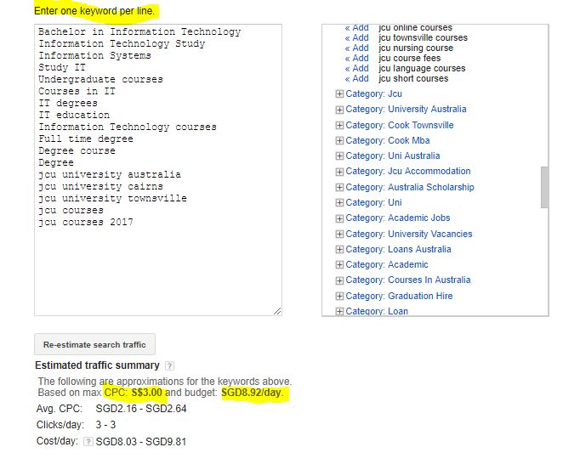

Image 8 – keywords for the part time courses campaign

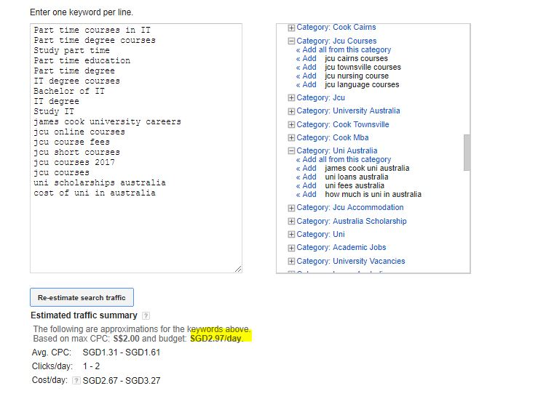

Image 9 – the Search network only settings

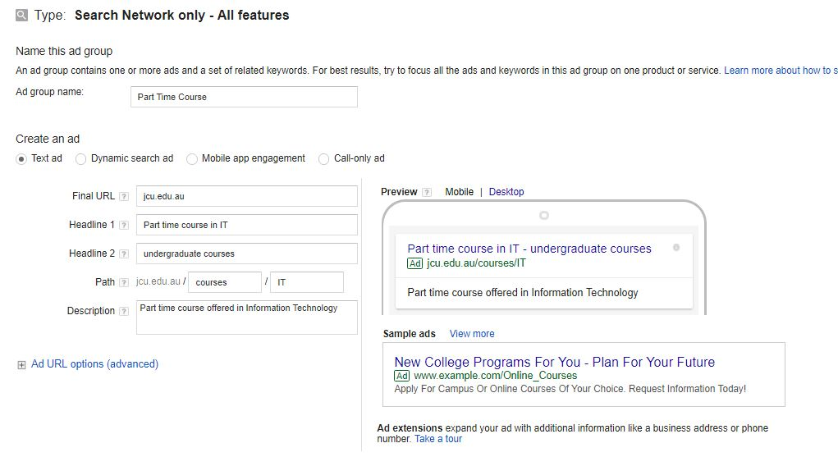

Image 10 – showing the daily forecasts and comparisons

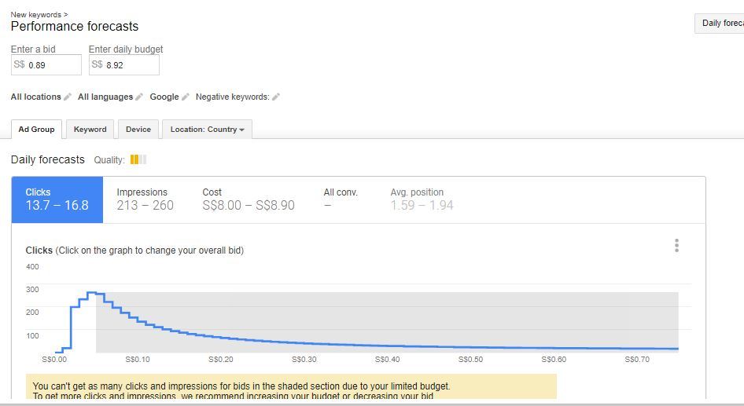

Image 11 – showing the impressions and the CPC and CTR rates

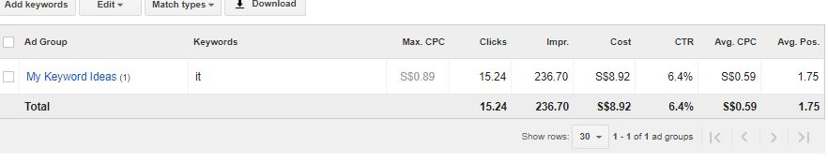

Image 12 – showing the campaign status

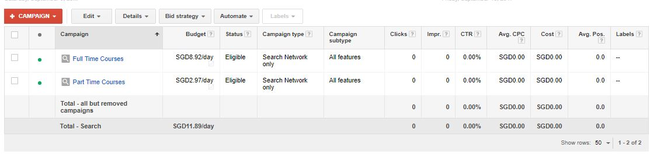

Image 13 – Showing the AdWords groups

